O'Keeffe
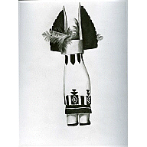
Kachina, (1934)
Georgia O'Keeffe (American, 1887–1986)
Charcoal on paper
25 1/4 x 19" (64.1 x 48.3 cm)
Given anonymously (by exchange)
D18.1936
Provenance:
1934 - December 20, 1935, Georgia O'Keeffe, Abiquiú, New Mexico.
December 20, 1935 - March 6, 1973, The Museum of Modern Art, New York, acquired from the artist through Alfred Stieglitz with 18.1936, 20.1936 and 21.1936 in exchange for 119.1935.
March 6, 1973 - 1986, Georgia O'Keeffe, Abiquiú, New Mexico, acquired from The Museum of Modern Art through Alfred Stieglitz with 20.1936 in exchange for 277.1972.
1986 - 1993, Estate of the artist, Abiquiú, New Mexico.
1995 - today, The Georgia O'Keeffe Foundation, Abiquiú, New Mexico.
Catalogue Raisonne:
Georgia O'Keeffe Foundation, 1999, vol. I, no. 824
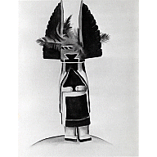
Kachina, 1934
Georgia O'Keeffe (American, 1887–1986)
Charcoal on paper
25 1/4 x 19" (64.1 x 48.3 cm)
Given anonymously (by exchange)
D20.1936
Provenance:
1934 - December 20, 1935, Georgia O'Keeffe, Abiquiú, New Mexico.
December 20, 1935 - March 6, 1973, The Museum of Modern Art, New York, acquired from the artist through Alfred Stieglitz with 18.1936, 19.1936 and 21.1936 in exchange for 119.1935.
March 6, 1973 - 1986, Georgia O'Keeffe, Abiquiú, New Mexico, acquired from The Museum of Modern Art through Alfred Stieglitz with 18.1936 in exchange for 277.1972.
1986 - 1993, Estate of the artist, Abiquiú, New Mexico.
1995 - today, The Georgia O'Keeffe Foundation, Abiquiú, New Mexico.
Catalogue Raisonne:
Georgia O'Keeffe Foundation, 1999, vol. I, no. 823
Page 1 of 8
O'Keeffe
Printed: 07/30/2019 04:49 PM

O'Keeffe

The Red Hills and Sun, September 1927
Georgia O'Keeffe (American, 1887–1986)
Oil on canvas
27 x 32" (68.6 x 81.3 cm)
Bequest of Richard D. Brixey
D109.1943
Provenance:
1927 - 1928, Georgia O'Keeffe, Abiquiú, New Mexico.
1928 - 1943, Richard De Wolfe Brixey, Bedford Hills, NY, acquired from the artist through Alfred Stieglitz.
May 21, 1943 - April 26, 1945, The Museum of Modern Art, New York, acquired by bequest from Richard De Wolfe Brixey.
April 26, 1945, Georgia O'Keeffe, Abiquiú, New Mexico, acquired from The Museum of Modern Art through Alfred Stieglitz in exchange for 144.1945.
1945 - today, The Phillips Collection, Washington, D.C., acquired from the artist through An American Place.
Catalogue Raisonne:
Georgia O'Keeffe Foundation, 1999, vol. I, no. 608

New Mexico Landscape, 1930
Georgia O'Keeffe (American, 1887–1986)
D119.1935
Provenance:
1930 - March 30, 1931, Georgia O'Keeffe, Abiquiú, New Mexico.
March 30, 1931 - June 13, 1935, Abby Aldrich Rockefeller, New York, purchased from the artist through Downtown Gallery, New York.
June 13, 1935 - December 20, 1935, The Museum of Modern Art, New York, acquired as gift from Abby Aldrich Rockefeller.
December 20, 1935 - 1946(?), Georgia O'Keeffe, Abiquiú, New Mexico, acquired from The Museum of Modern Art through Alfred Stieglitz in exchange for 18.1936, 19.1936, 20.1936 and 21.1936.
[...]
1988, Private Collection
Catalogue Raisonne:
Georgia O'Keeffe Foundation, 1999, vol. I, no. 725
Page 2 of 8
O'Keeffe
Printed: 07/30/2019 04:49 PM

O'Keeffe
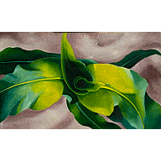
(Green leaves), n.d
Georgia O'Keeffe (American, 1887–1986)
Oil on canvas
18 x 29 1/8" (45.7 x 74.0 cm)
18 x 29 1/8" (45.7 x 74 cm)
Gift of Charles B. Mergentime
D825.1963
Provenance:
1924, Georgia O'Keeffe, Abiquiú, New Mexico.
1924 - December 18, 1958, Charles B. Mergentime, New York, acquired from the artist through Alfred Stieglitz.
December 18, 1958 - December 1, 2005, The Museum of Modern Art, New York, acquired as gift from Charles B. Mergentime.
Sold at auction Important American Paintings, Drawings and Sculpture, Christie's, New York, lot no. 126
Catalogue Raisonne:
Georgia O'Keeffe Foundation, 1999, vol. I, no. 456
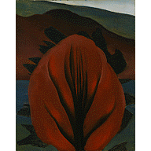
Flower, 1900-1942
Georgia O'Keeffe (American, 1887–1986)
Oil on canvas
18 1/2 x 15" (47.0 x 37.8 cm)
Gift of Florence Cane
D826.1963
Provenance:
1921, Georgia O'Keeffe, Abiquiú, New Mexico.
(February 23?) 1922 - 1942, Florence Cane, New York, NY, probably purchased at auction The Anderson Galleries, New York, lot no. 48.
1942 - December 1, 2005, The Museum of Modern Art, New York, acquired from Florence Cane as donation for the Art Sale for the Armed Services.
Sold at auction Important American Paintings, Drawings and Sculpture, Christie's, New York, lot no. 127
Catalogue Raisonne:
Georgia O'Keeffe Foundation, 1999, vol. I, no. 359
Page 3 of 8
O'Keeffe
Printed: 07/30/2019 04:49 PM

O'Keeffe
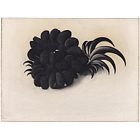
Eagle Claw and Bean Necklace, (1934)
Georgia O'Keeffe (American, 1887–1986)
Charcoal on paper
19 x 25 1/8" (48.5 x 63.9 cm)
Given anonymously (by exchange)
19.1936
Provenance:
December 20, 1935, The Museum of Modern Art, New York, acquired from the artist through Alfred Stieglitz with 18.1936, 20.1936 and 21.1936 in exchange for 119.1935.
Catalogue Raisonne:
Georgia O'Keeffe Foundation, 1999, vol. I, no. 829
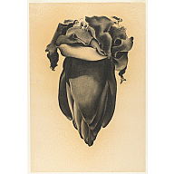
Banana Flower, 1934
Georgia O'Keeffe (American, 1887–1986)
Charcoal on paper
21 3/4 x 14 3/4" (55.2 x 37.7 cm)
Given anonymously (by exchange)
21.1936
Provenance:
December 20, 1935, The Museum of Modern Art, New York, acquired from the artist through Alfred Stieglitz with 18.1936, 19.1936 and 20.1936 in exchange for 119.1935.
Catalogue Raisonne:
Georgia O'Keeffe Foundation, 1999, vol. I, no. 830
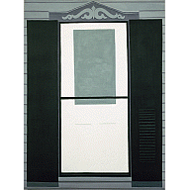
Farmhouse Window and Door, October 1929
Georgia O'Keeffe (American, 1887–1986)
Oil on canvas
40 x 30" (101.6 x 76.2 cm)
Acquired through the Richard D. Brixey Bequest
144.1945
Provenance:
1929 - April 26, 1945, Georgia O'Keeffe, Abiquiú, New Mexico.
April 26, 1945, The Museum of Modern Art, New York, purchased and acquired from the artist through An American Place (Alfred Stieglitz) in exchange for 109.1943.
Catalogue Raisonne:
Georgia O'Keeffe Foundation, 1999, vol. I, no. 653
Page 4 of 8
O'Keeffe
Printed: 07/30/2019 04:49 PM

O'Keeffe
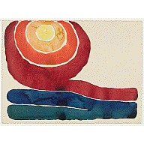
Evening Star, No. III, 1917
Georgia O'Keeffe (American, 1887–1986)
Watercolor on paper mounted on board
8 7/8 x 11 7/8" (22.7 x 30.4 cm)
Mr. and Mrs. Donald B. Straus Fund
91.1958
Provenance:
1917 - April 22, 1958, , Georgia O'Keeffe, Abiquiú, New Mexico.
April 22, 1958, The Museum of Modern Art, New York, purchased from the artist through Downtown Gallery, New York.
Catalogue Raisonne:
Georgia O'Keeffe Foundation, 1999, vol. I, no. 201
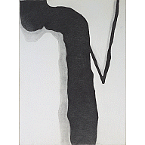
Drawing X, 1959
Georgia O'Keeffe (American, 1887–1986)
Charcoal on paper
24 7/8 x 18 5/8" (63.2 x 47.3 cm)
Gift of Abby Aldrich Rockefeller (by exchange)
277.1972
Provenance:
1959 - October 2, 1972, Georgia O'Keeffe, Abiquiú, New Mexico.
October 2, 1972, The Museum of Modern Art, New York, acquired from the artist through Doris Bry, New York in exchange for 18.1936 and 20.1936.
Catalogue Raisonne:
Georgia O'Keeffe Foundation, 1999, vol. II, no. 1340
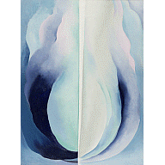
Abstraction Blue, 1927
Georgia O'Keeffe (American, 1887–1986)
Oil on canvas
40 1/4 x 30" (102.1 x 76 cm)
Acquired through the Helen Acheson Bequest
71.1979
Provenance:
Georgia O'Keeffe, Abiquiú, New Mexico.
1959 - [January 30, 1979], Dr. Helen Boignon, New York, probably purchased from the artist through Downtown Gallery, New York.
January 30, 1979, The Museum of Modern Art, New York, purchased from a private collection (probably Helen Boignon), New York through Hirschl & Adler Galleries (Norman Hirschl), New York.
Catalogue Raisonne:
Georgia O'Keeffe Foundation, 1999, vol. I, no. 573
Page 5 of 8
O'Keeffe
Printed: 07/30/2019 04:49 PM

O'Keeffe
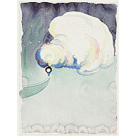
Train at Night in the Desert, (1916)
Georgia O'Keeffe (American, 1887–1986)
Watercolor and pencil on paper
11 7/8 x 8 7/8" (30.3 x 22.5 cm)
Acquired with matching funds from the Committee on Drawings and the National Endowment for the Arts
113.1979
Provenance:
1916 - June 15, 1977, Georgia O'Keeffe, Abiquiú, New Mexico.
June 15, 1977, The Museum of Modern Art, New York, purchased from the artist through Doris Bry, New York.
Catalogue Raisonne:
Georgia O'Keeffe Foundation, 1999, vol. I, no. 129
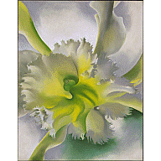
An Orchid, (1941)
Georgia O'Keeffe (American, 1887–1986)
Pastel on paper mounted on board
27 5/8 x 21 3/4" (70.2 x 55.2 cm)
Bequest of Georgia O'Keeffe
556.1990
Provenance:
Georgia O'Keeffe, Abiquiú, New Mexico.
By 1965, Anita O'Keeffe (Mrs. Robert R.) Young, Newport, Rhode Island.
Georgia O'Keeffe, Abiquiú, New Mexico.
1986 - 1987, Estate of the artist, Abiquiú, New Mexico.
1987, The Museum of Modern Art, New York, acquired as bequest from the Estate of the artist.
Catalogue Raisonne:
Georgia O'Keeffe Foundation, 1999, vol. II, no. 1017
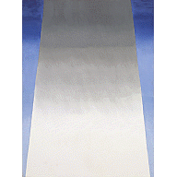
From a Day with Juan II, 1977
Georgia O'Keeffe (American, 1887–1986)
Oil on canvas
48 x 36" (122 x 96 cm)
Georgia O'Keeffe Bequest
447.1994
Provenance:
1977 - 1986, Georgia O'Keeffe, Abiquiú, New Mexico.
1986 - 1987, Estate of the artist, Abiquiú, New Mexico.
1987, The Museum of Modern Art, New York, acquired as bequest from the Estate of the artist.
Catalogue Raisonne:
Georgia O'Keeffe Foundation, 1999, vol. II, no. 1626
Page 6 of 8
O'Keeffe
Printed: 07/30/2019 04:49 PM

O'Keeffe
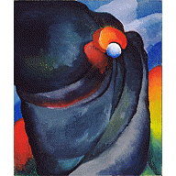
Lake George, Coat and Red, 1919
Georgia O'Keeffe (American, 1887–1986)
Oil on canvas
27 3/8 x 23 1/4" (69.6 x 59 cm)
Gift of The Georgia O'Keeffe Foundation
65.1995
Provenance:
1919 - 1986, Georgia O'Keeffe, Abiquiú, New Mexico.
1986 - 1993, Estate of the artist, Abiquiú, New Mexico.
1993 - December 27, 1994, The Georgia O'Keeffe Foundation, Abiquiú, New Mexico.
December 27, 1994, The Museum of Modern Art, New York, acquired as gift from The Georgia O'Keeffe Foundation.
Catalogue Raisonne:
Georgia O'Keeffe Foundation, 1999, vol. I, no. 289
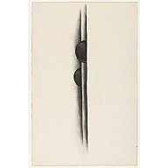
Special No. 39, (1919)
Georgia O'Keeffe (American, 1887–1986)
Charcoal on paper
19 5/8 x 12 3/4" (49.8 x 32.4 cm)
Gift of The Georgia O'Keeffe Foundation
199.1995
Provenance:
1919 - 1986, Georgia O'Keeffe, Abiquiú, New Mexico.
1986 - 1993, Estate of the artist, Abiquiú, New Mexico.
1993 - December 27, 1994, The Georgia O'Keeffe Foundation, Abiquiú, New Mexico.
December 27, 1994, The Museum of Modern Art, New York, acquired as gift from The Georgia O'Keeffe Foundation.
Catalogue Raisonne:
Georgia O'Keeffe Foundation, 1999, vol. I, no. 281
Page 7 of 8
O'Keeffe
Printed: 07/30/2019 04:49 PM

O'Keeffe
No. 12 Special, (1916)
Georgia O'Keeffe (American, 1887–1986)
Charcoal on paper
24 x 19" (61 x 48.3 cm)
Gift of The Georgia O'Keeffe Foundation
200.1995
Provenance:
1916 - 1986, Georgia O'Keeffe, Abiquiú, New Mexico.
1986 - 1993, Estate of the artist, Abiquiú, New Mexico.
1993 - December 27, 1994, The Georgia O'Keeffe Foundation, Abiquiú, New Mexico.
December 27, 1994, The Museum of Modern Art, New York, acquired as gift from The Georgia O'Keeffe Foundation.
Catalogue Raisonne:
Georgia O'Keeffe Foundation, 1999, vol. I, no. 117
Page 8 of 8
O'Keeffe
Printed: 07/30/2019 04:49 PM
